**•The selected dataset:**

-We used Credit Card Customer Data.

**•Your model (k, error function):**

-We applyed kmean clustering with K=5, and the error function is Sum of squares (Euclidean distance)

**•Plotting a graph of your clustered data**

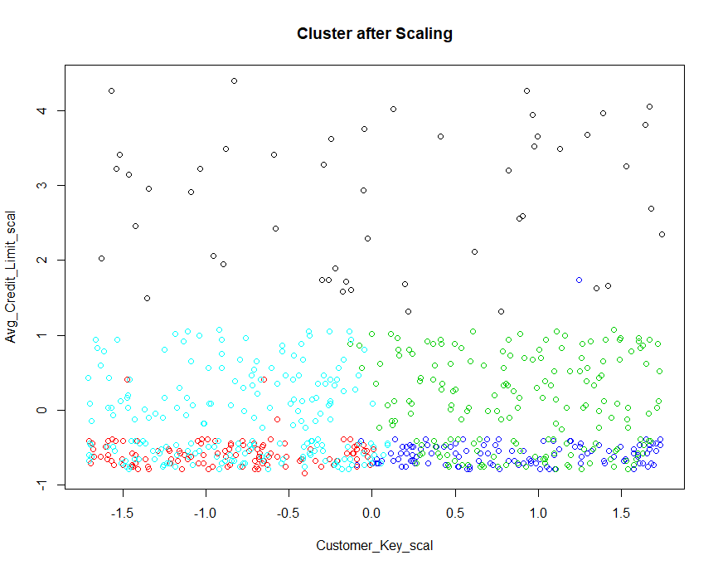

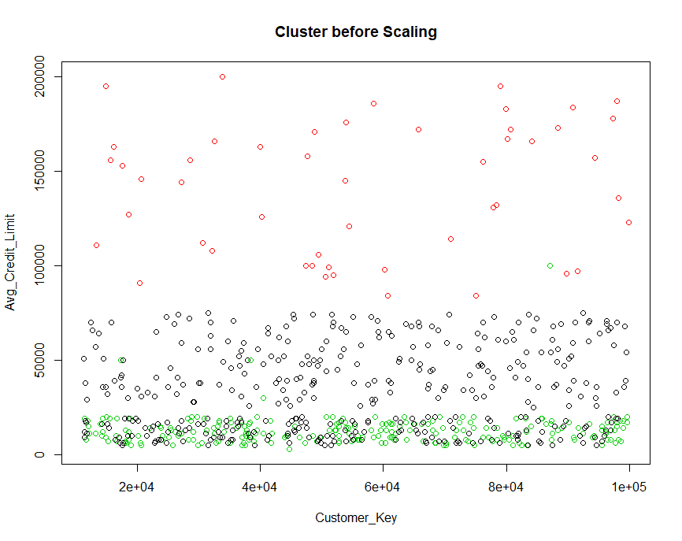

**•Justification of the clustered result.**

-First we Evaluate the model to find the optimal K which is 5

Then We used 5 clusters (K=5) to cluster data of 2 features (Customer _Key, Avg_Credit_Limit) from the Credit Card Customer Data and before it we scaled the data using scale function of (dplyr) library and this is the result:

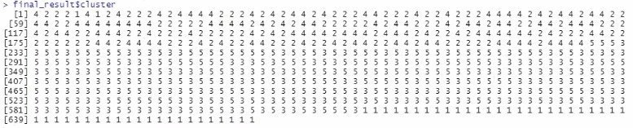

(And this show the cluster of each observation)

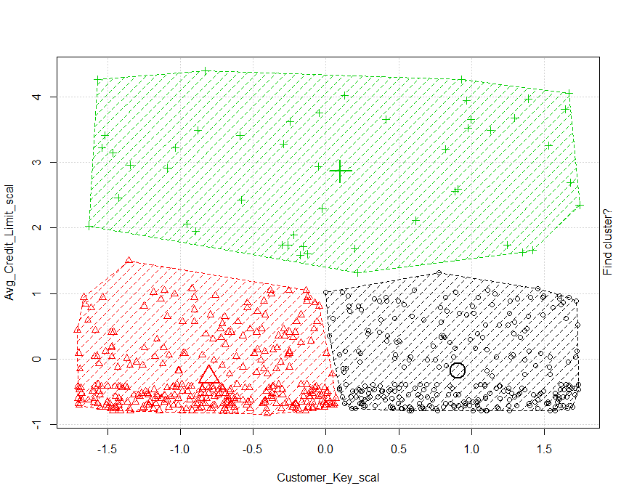

(This show the cluster using k=3)

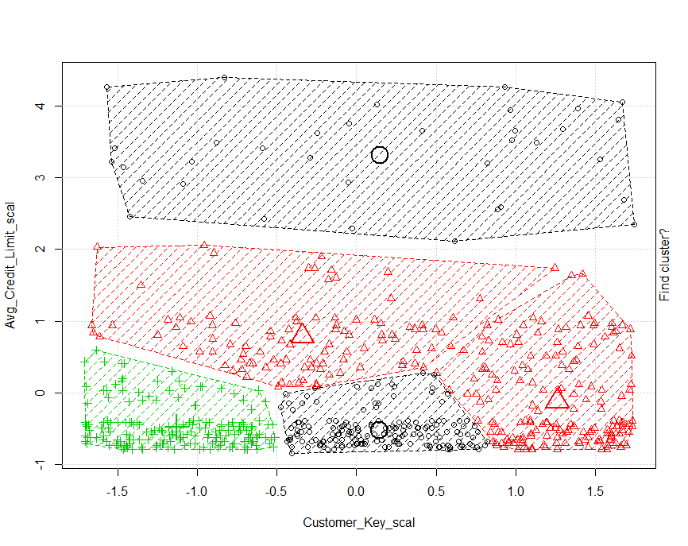(This show the cluster using k=5)